Week In Review Issue 6: Dec 7-13
Alex Shvartsman

Grand Prix: Singapore
This was the last Grand Prix of the season, leaving this columnist to wonder exactly what he is going to write about later this month.
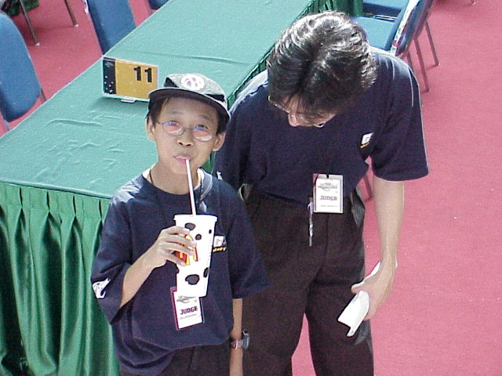
This tournament gathered a crowd of just over 200 players. Although none of the American pros chose to travel there in search of points and glory (we must be too tired after Chicago), several American players from the Seattle area did attend and finished reasonably well, bagging 19th and 23rd place finishes.
The top prize of the tournament went to Sam Lau playing a Trix deck. Although you might recognize the name from Canadian Nationals coverage this summer, it is actually a different person. This Sam Lau is from Singapore and (probably) has never been to Canada. Among other Top 8 finishers, the recognized pros include Japanese notable Masayuki Higashino and Singapore's own best-known player Nick Wong (and his duck).
Complete coverage of GP Singapore along with deck lists may be found here on The Sideboard.

Grudge Match 2
Top 32 players in New York and Boston areas competed for $2000 prize purse each and a chance to play on behalf of their club in a $1000 ante match.

Unfortunately, Your Move Games has not posted any information on their web site about the event, so all I know is that Joe "Mouth" Kambourakis won that event with a copy of Kibler's R/G/w PT Chicago deck. Kambourakis is probably the only player in Boston that can show up at a Grudge Match and easily live up to the trash-talking legacy of previous Boston winner Tom Guevin, guaranteeing that the final match will be worth watching.
In New York, Zvi Mowshowitz not only managed to qualify in the very last "grinder" (single elimination qualifier), he managed to defeat the field and win first place with his PT Chicago deck. Yours truly missed the Top 8 on tiebreakers and was left with a prizeless 9th place finish.
The final match predictions are heavily for Zvi. Then again, last year everyone expected Guevin to crush the unknown James Bradley, but the exact opposite thing happened. The final match is going to take place at Grand Prix: New Orleans in a few weeks. The format is to be announced.
Some coverage of this event may be found on Neutral Ground Online.

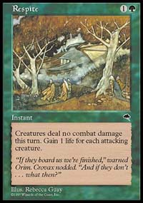
Coming Up: A Brief Respite
With no title events in upcoming weeks and no Constructed Pro Tour, Masters or even Grand Prix to playtest for, the Pro players are taking some time off working on Magic. The next major tournament will take place in early January, at which point a normal weekly schedule of Grand Prix and an occasional Pro Tour will resume.

Auction of Champions has begun
As reported earlier in this column, StarCityGames.com will be auctioning off the Pro Tour winning decks used at this year's Magic Invitational and signed by the players. Part of the proceeds will go to the Make a Wish Foundation. The first two decks are up and the bidding is relatively heavy. For more details, visit the Star City web site.

Meridian Magic is back

As of Wednesday, December 13 Meridian Magic digest web site is back online. Originally started by Cathy Nicoloff, Meridian quickly rose through the ranks of strategy web sites to become one of the most visited Magic locations on the Web. Its formula for success was very simple - sift through tons of Internet content and present the reader with the best writing and most useful information.
The site has now been resurrected after a long hiatus. Check it out.

Best of the Net
Pro Tour Chicago is over and the tournament reports from the winners are pouring in. You can find reports by the champion Kai Budde, and top 8 finishers Zvi Mowshowitz and Mike Pustilnik.

Play of the Week
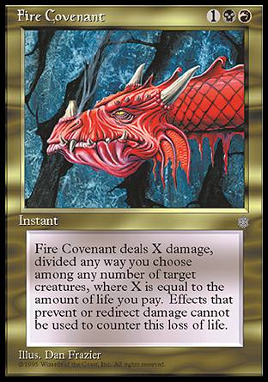
Two Trix decks were facing each other at Grand Prix: Singapore (the names shall be left out to protect the innocent). Player A chose the standard route of bringing in some beatdown creatures after sideboard. Player B decided to be cute and bring in Mike Pustilnik's tech from GP Buenos Aires - Fire Covenant.
Things looked grim for Player B as he was facing both Masticore and Phyrexian Negator on the other side of the table. But he saw his chance to get out of the bind - he cast Fire Covenant targeting Player A's Negator and paying enough life to leave his opponent with no permanents on the table. However, he forgot one minor detail. Player A had two mana untapped.
Player A used his Masticore to deal one point of damage to the Negator in response, then sacrificed Negator to satisfy its own ability. Fire Covenant had no target anymore, but player B still ended up losing X life and was quickly subdued by the Masticore.
And thus ends another Week In Review. If you have some interesting anecdotes, play of the week, or other stories that you think should make it onto these pages, please e-mail me at ashv@concentric.net.

